Portfolio Combination

# Download data and calculate monthly returns

Data of MSFT, YHOO, ORCL, EBAY, CSCO have been downloaded from the Yahoo Finance. Based on this data monthly returns for all stocks have been calculated. The results are listed in the table below.

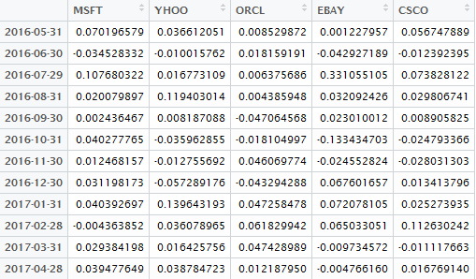

Figure 1 - Stocks Monthly Returns

# Portfolios Combinations

Using the combination function 10 possible portfolios have been created.

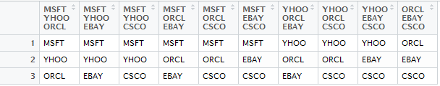

Figure 2 - All possible combinations from 3 stocks

Monthly portfolios returns presented below:

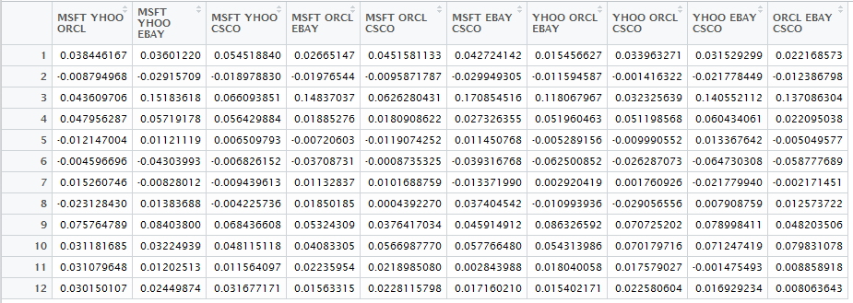

Figure 3 - Portfolios Monthly Returns

# Corresponding Statistics

For each portfolio mean, median and standard deviation have been calculated.

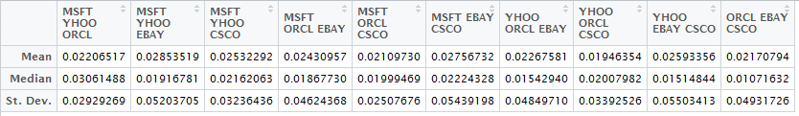

Figure 4 - Portfolio Statistics

What is interesting here is that, having rather close values of mean (average portfolio return), risk (standard deviation) significantly differs.

For example: the portfolio that consists of MSFT, ORCL, CSCO has standard deviation **0.02507676** that comparing with **0.05503413** (YHOO, EBAY, CSCO) is more than 2 times less! Note, difference in mean is negligible comparing with the difference in risk (only about 20%, moreover in case of median less risky portfolio provides better result)

# Histograms, Cumulative returns and Distributions

Graphical summary about returns and distributions is presented below.

Conclusion about the distribution is made based on Shapiro - Wilk test with 95% result confidence.

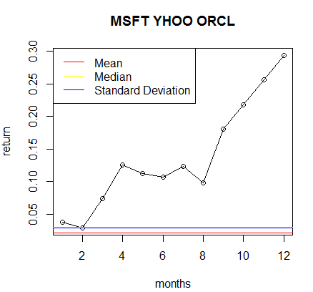

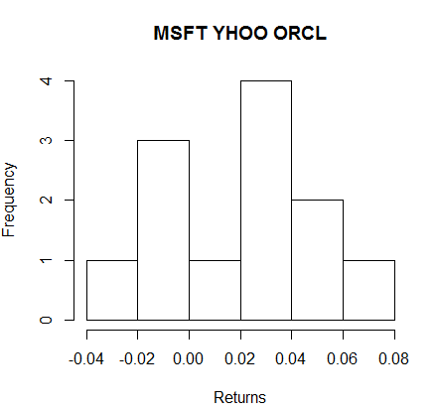

Distribution is Normal ( Shapiro test p.value = 0.655228487013165 )

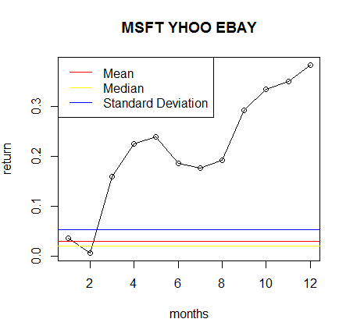

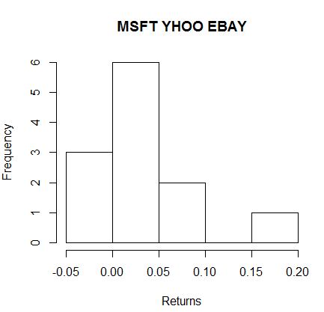

Distribution is Normal(Shapiro test p.value = 0.312431107501377)

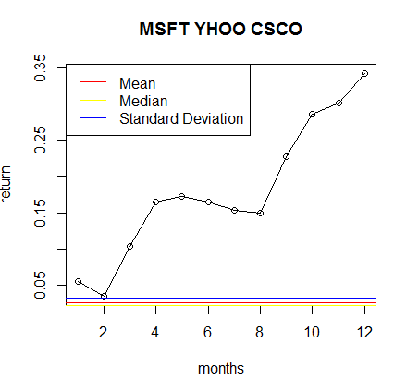

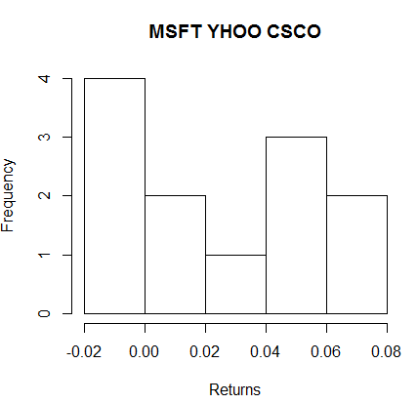

Distribution is Normal( Shapiro test p.value = 0.140340799279875 )

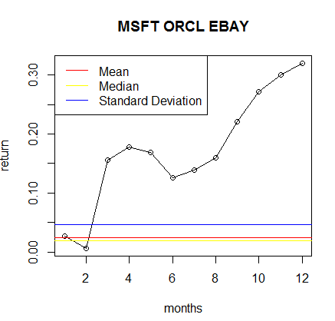

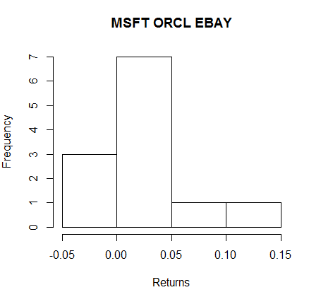

Distribution is not Normal (Shapiro test p.value = 0.0240113321543593)

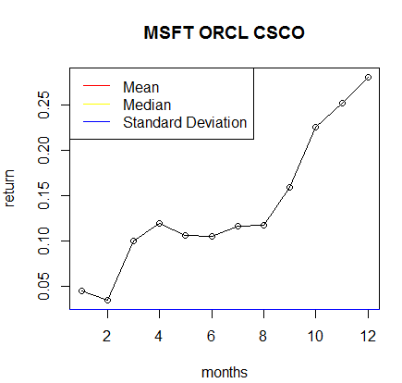

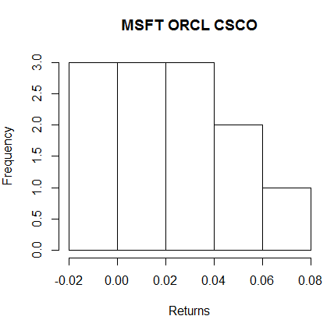

Distribution is Normal (Shapiro test p.value = 0.561524785613415)

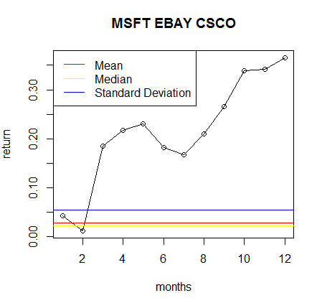

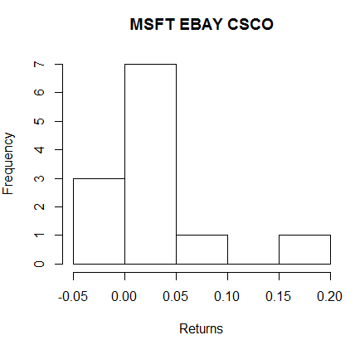

Distribution is not Normal ( Shapiro test p.value = 0.0471921762943291)

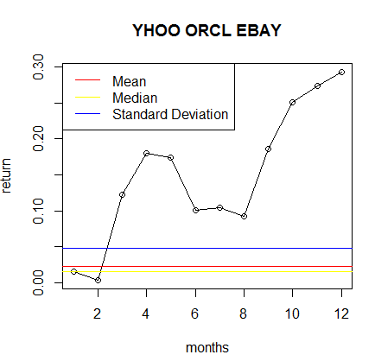

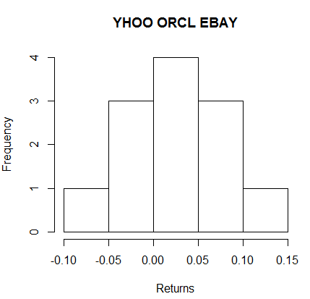

Distribution is Normal ( Shapiro test p.value = 0.71813067169187 )

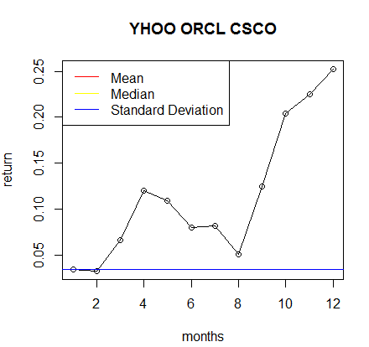

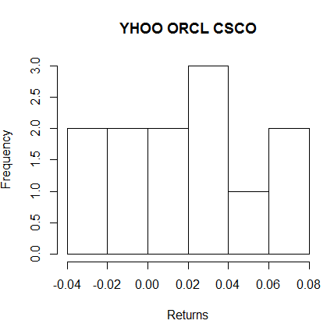

Distribution is Normal ( Shapiro test p.value = 0.633572209227691 )

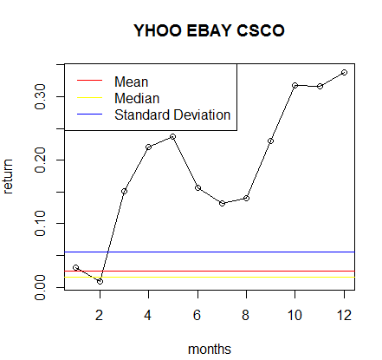

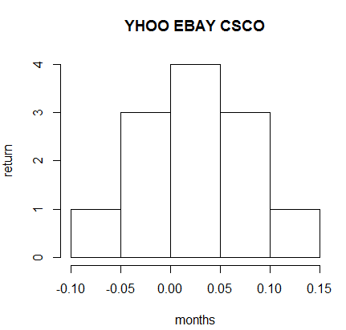

Distribution is Normal ( Shapiro test p.value = 0.918631005198233 )

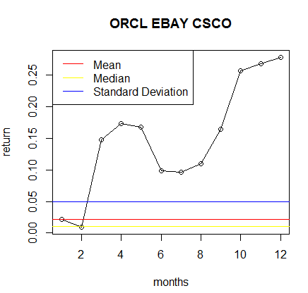

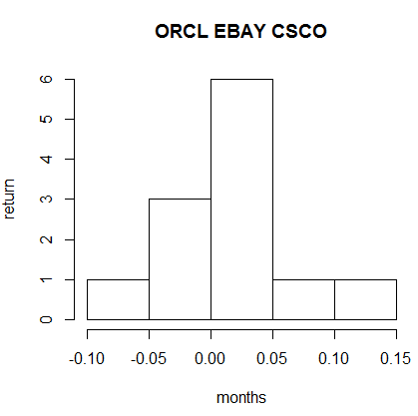

Distribution is Normal ( Shapiro test p.value = 0.187516499192971 )

# General variance

Based on R calculations, general variance of monthly return is **0.00179222443063089**

# Conclusion

* As was shown above there are normally and non-normally distributed returns.
* There is noticeable difference in returns of different portfolios, but the most interesting result is that, varying stocks in portfolio, it is possible to reduce risk significantly without any loses in revenue.
* Taking into consideration the fact that all of the companies being analyzed here, are from the same industry, it is clear that companies features (such as finance reports, news, gossips and so on) are the main influence factor for the price movement.